BANSAL COLLEGE OF ENGINEERING
MANDIDEEP


A
MAJOR PROJECT REPORT
ON
“Project Title”

Submitted in partial fulfillment of Bachelor of Engineering Degree in Computer Science & Engineering
of

RAJIV GANDHI PROUDYOGIKI VISHWAVIDYALAY
BHOPAL


Submitted By:

Name:
Enrollment No.:

Session 2022 - 2023

BANSAL COLLEGE OF ENGINEERING MANDIDEEP

(COMPUTER SCIENCE & ENGINEERING)

CERTIFICATE

This is to certify that project report entitled “PROJECT NAME” presented by STUDENT NAME (Enrollment No. 0127CS) is the bonafide presentation of the work done by them under my supervision and guidance. The project report has been submitted towards partial fulfillment for the award of degree of Bachelor of Engineering of Rajiv Gandhi Prodyogiki Vishwavidhyalay, Bhopal during the academic year 2022-23.It is further certified that this work has not been submitted elsewhere for the award of any degree or diploma.

Approved By  (Prof. Sunil Kumar)  HOD  Department of CSE |  | Guided By  (Prof. )  Asst.Prof.(CSE)  Department of CSE
(Prof. Vivek Kumar Soni)  Asst.Prof. and Project Incharge  Department of CSE | Asst.
(Dr. R. Rawat)
Director, BCE Mandideep

Project Title

OUR GROUP MEMBERS:
1. NAME (ENROLLMENT NUMBER)
2. NAME (ENROLLMENT NUMBER)
3. NAME (ENROLLMENT NUMBER)
4. NAME (ENROLLMENT NUMBER)
5. NAME (ENROLLMENT NUMBER)

MY PERSONAL CONTRIBUTION IN THE PROJECT:

Resume template is designed by me, I used HTML, CSS, Bootstrap (grids, text, buttons) to design front-end of our website .
Apart from this, Server Connectivity is done by me using PHP and some modules of Javascript is implemented by me.
I have given the logic behind our website.

ACKNOWLEDGEMENT

We are deeply indebted to the faculty, colleagues, friends and professionals from allied fields, who have offered their guidance, insights and support throughout the development of this project. Foremost among the faculty our gratitude is due to Dr. R. Rawat (Director, BCE Mandideep) for providing us the motivation and the necessary facilities. We are equally thankful to Prof. Sunil Kumar, HOD (CSE) for his support and helpfulness in selecting, designing and testing of our project. We at the same time cannot forget to thank deeply our Project Guide- Prof., Asst. Professor (CSE) & Project Incharge- Mr. Vivek Kumar Soni , Asst. Professor (CSE) for guiding, helping at every stage and providing us the time and resources necessary to develop ideas and concept of the project.
This project would not have been successfully completed without the support, patience and love of all those near to us. Our special thanks to lab technician of the Project Lab for supporting us technically. Also we are thankful to all the faculty members for their help whenever we needed.
In the end we thank our parents and The Almighty for their blessings, without which the project would not have been completed.

Group members:
- Name (Enrollment Number)
- Name (Enrollment Number)
- Name (Enrollment Number)
- Name (Enrollment Number)
- Name (Enrollment Number)

INDEX
CONTENTS | PAGES NO.
- INTRODUCTION | 1
- LITERATURE SURVEY
- PROBLEM STATEMENT
- SYSTEM REQUIREMENT  - HARDWARE REQUIREMENT  - SOFTWARE REQUIREMENT | 2
- TOOLS/TECHNOLOGY USED  - TOOLS  - TECHNOLOGY | 3-5
- SOFTWARE MODEL USED | 6-7
- SYSTEM DESIGN  - DATA FLOW DIAGRAMS  - CONTROL FLOW DIAGRAM | 8-9
- TESTING | 10-11
- SNAPSHOTS  - HOME PAGE  - RESUME FROM PAGE  - PAGE AFTER SUBMISSION | 12-15
- CONCLUSION | 33
- LIMITATIONS | 34
- FUTURE ENHANCEMENTS | 35
- BIBLIOGRAPHY | 36

- INTRODUCTION
A resume is a formal document that a job applicant creates to itemize their qualifications for a position. A resume is usually accompanied by a customized cover letter in which the applicant expresses an interest in a specific job or company and draws attention to the most relevant specifics on the resume.
A strong resume communicates your qualifications and sets you up for career success.
As placement season of most of the colleges is going to start, making Resume is a very hectic work for all the students. Also, many companies judge the candidature of a student just by his/her Resume. So it is necessary for the student to think beyond the third dimension while making the Resume.
- Automated Resume Builder is the Web Application which helps students to get their resume in hand just by filling up a simple form where important credentials need to be filled.
- The resume is downloadable in PDF format. Also, the user can log in again to access the previous resume that he had made
- The resume is of Standard Format as stated by most of the Engineering Colleges of India.

- .

2. SYSTEM REQUIREMENT
2.1 HARDWARE REQUIREMENTS
- Processor CPU with 1.7GHz & above Frequency
- RAM 2GB RAM or above
- Min Hard Disk- 20 GB
2.2 SOFTWARE REQUIREMENTS
- XAMPP SERVER
- Google Chrome
- Internet Connection

3. TOOLS/TECHNOLOGY USED
3.1 TOOLS
3.1.1 FRONT END
- HTML
- CSS
- Javascript
- Bootstrap Grids , buttons
3.1.2 CONNECTIVITY
- PHP Server
- Internet connection
3.1.3 SOFTWARE USED
- XAMPP
- Visual Studio Code
- Google chrome

3.2 TECHNOLOGY

- PHP
PHP is an open-source, interpreted, and object-oriented scripting language that can be executed at the server-side. PHP is well suited for web development. Therefore, it is used to develop web applications (an application that executes on the server and generates the dynamic page.).
- CSS
Cascading Style Sheets, fondly referred to as CSS, is a simply designed language intended to simplify the process of making web pages presentable. CSS allows you to apply styles to web pages. More importantly, CSS enables you to do this independent of the HTML that makes up each webpage. CSS is easy to learn and understand, but it provides powerful control over the presentation of an HTML document.
- Javascript
JavaScript is the world most popular lightweight, interpreted compiled programming language. It is also known as scripting language for web pages. It is well-known for the development of web pages, many non-browser environments also use it. JavaScript can be used for Client-side developments as well as Server-side developments.
- HTML
HTML stands for HyperText Markup Language. It is used to design web pages using a markup language. HTML is the combination of Hypertext and Markup language. Hypertext defines the link between the web pages. A markup language is used to define the text document within tag which defines the structure of web pages.
HTML is a markup language that is used by the browser to manipulate text, images, and other content to display in the required format.
- Bootstrap
Bootstrap is a free and open-source tool collection for creating responsive websites and web applications. It is the most popular HTML, CSS, and JavaScript framework for developing responsive, mobile-first websites. Nowadays, the websites are perfect for all the browsers (IE, Firefox, and Chrome) and for all sizes of screens (Desktop, Tablets, Phablets, and Phones). All thanks to Bootstrap developers – Mark Otto and Jacob Thornton of Twitter, though it was later declared to be an open-source project.
- PhpMyAdmin
phpMyAdmin is an open-source software tool introduced on September 9, 1998, which is written in PHP. Basically, it is a third-party tool to manage the tables and data inside the database. phpMyAdmin supports various type of operations on MariaDB and MySQL. The main purpose of phpMyAdmin is to handle the administration of MySQL over the web
- XAMPP
XAMPP is one of the widely used cross-platform web servers, which helps developers to create and test their programs on a local webserver. It was developed by the Apache Friends, and its native source code can be revised or modified by the audience. It consists of Apache HTTP Server, MariaDB, and interpreter for the different programming languages like PHP and Perl.
- Visual-Studio-Code
Visual Studio Code is a source-code editor made by Microsoft for Windows, Linux and macOS .[9] Features include support for debugging, syntax highlighting, intelligent code completion, snippets, code refactoring, and embedded Git. Users can change the theme, keyboard shortcuts, preferences, and install extensions that add additional functionality.

4. SOFTWARE MODEL USED
4.1 WATERFALL MODEL
In Royce's original waterfall model, the following phases are followed in order:
- System and software requirements: captured in a product repairements document
- Analysis resulting in mo schema, and business rules
- Design resulting in the software architecture. .
- Coding the development, proving, and integration of software
- Testing the systematic discovery and debugging of defects
- Operations the installation, migration, support, and maintenance of complete system
Thus the waterfall model maintains that one should move to a phase only when its preceding phase is reviewed and verified. Various modified waterfall models (including Royce's final model), however, can include slight or major variations on this process. These variations included returning to the previous cycle after flaws were found downstream, or returning all the way to the design phase if downstream phases deemed insufficient.
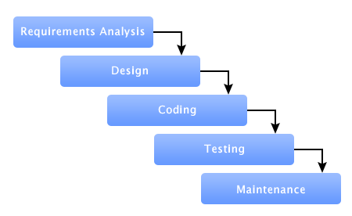
Fig. 4.1 Waterfall model

Advantages
- Before the next phase of development, each phase must be completed
- Suited for smaller projects where requirements are well define
- They should perform quality assurance test (Verification and Validation)
- Elaborate documentation is done at every phase of the software's development cycle
- Project is completely dependent on project team with minimum client intervention.
- Any changes in software is made during the process of the development.
Disadvantages
- Error can be fixed only during the phase
- It is not desirable for complex project where requirement changes frequently.
- Testing period comes quite late in the developmental process
- Clients valuable feedback cannot be included with ongoing development phase
- Documentation occupies a lot of time of developers and testers.
- Small changes or errors that arises in the complete software may cause a lot of problems.
5. SYSTEM DESIGN
5.1 Data Flow Diagram
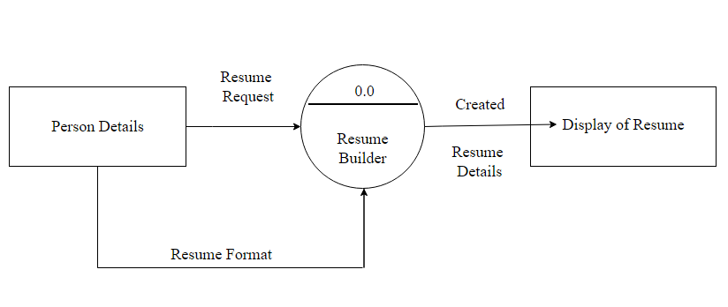Fig. 5.1 Data Flow Diagram

5.2 Control Diagram for Resume-form

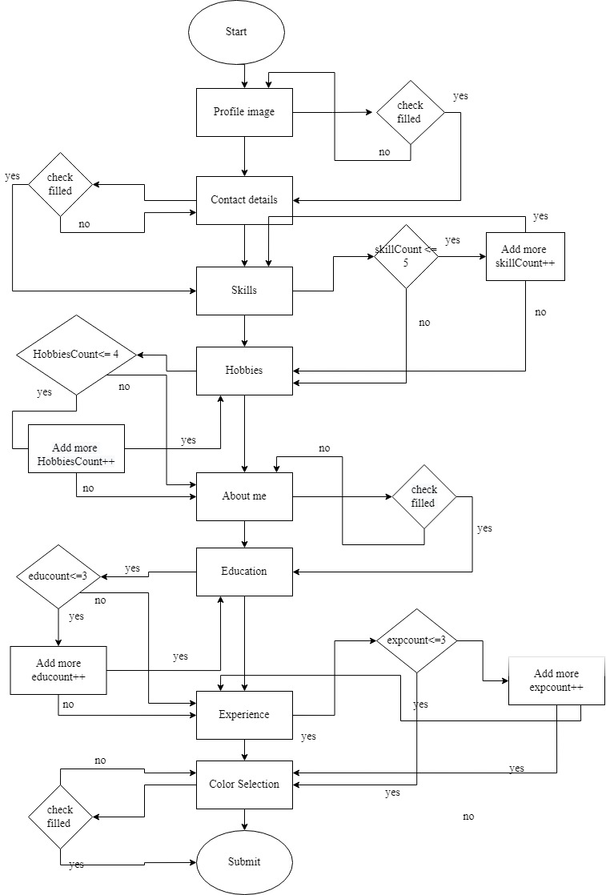
Fig.5.2 Control flow diagram

6. TESTING
Unit Testing is a level of software testing where individual unity components of a software are tested. The purpose is to validate that each unit of the software performs as designed. A unit is the smallest testable part of any software. It usually has one or a few inputs and usually a single output. In procedural programming, a unit may be an individual program, function, procedure, etc. In object-oriented programming, the smallest unit is a method, which may belong to a base super class, abstract class of derived child class. (Some treat a module of an application as a unit: This is to be discouraged as there will probably be many individual units within that modules. Unit testing frameworks, drivers, stubs, and mock/ fake objects are used to assist in unit testing.
Unit Testing Tips:
- Find a tool framework for your language Do not create test cases for everything Instead, focus on the tests that impact the behaviour of the system. Isolate the development environment from the test environment.
- Use test data that is close to that of production.
- Before fixing a defect, write a test that exposes the defect. Why? First, you will later be able to catch the defect if you do not fix it properly. Second, your test suite is now more comprehensive. Third, you will most probably be too lazy to write the test after you have already fixed the defect. Write test cases that are independent of each other. For example, if a class depends on a database, do not write a case that interacts with the database to test the class. Instead, create an abstract interface around that database connection and implement that interface with a mock object.
- Aim at covering all paths through the unit. Pay particular attention to loop conditions.
- Make sure you are using a version control system to keep track of your test scripts. In addition to writing cases to verify the behaviour, write cases to ensure the performance of the-code.
- Perform unit tests continuously and frequently.

6.1 Integration testing
Integration testing is a level of software testing where individual units are combined and tested as a group. The purpose of this level of testing is to expose faults in the interaction between integrated units. Test drivers and test stubs are used assist in Integration Testing Integration testing. Testing performed to expose defects in the interfaces and in the interactions between integrated components or systems. See also component integration testing, system integration testing.
6.2 Component Integration Testing
Testing performed to expose defects in the interfaces an interaction between integrated components system integration testing. Testing the integration of systems and packages testing interfaces to external organizations (eg. Electronic Data Interchange, Internet) that you have a proper Detail Design document where interactions between each unit are clearly defined. In fact, you will not be able to perform Integration Testing without this information:
Ensure that you have a robust Software Configuration Management system in place. Or else, you will have a tough time tracking the right version of each unit, especially if the number of units to be integrated is huge Make sure that each unit is unit tested before you start Integration Testing. As far as possible, automate your tests, especially when you use the Top Down or Bottom Up approach, since regression testing is important each time you integrate a unit, and manual regression testing can be inefficient.
6.3 Functional testing
It is a type of software testing whereby the system is tested against the functional requirements specifications. Functions (or features) are tested by feeding them input and examining the output. Functional testing ensures that the requirements are properly satisfied by the application. This type of testing is not concerned with how processing occurs, but rather, with the results of processing. It simulates actual system usage but does not make any system structure. This type of testing is not concerned with how processing occurs, but rather, with the results of processing. It simulates actual system usage but does not make any system structure assumptions.
During functional testing, Black Box Testing technique is used in which the internal logic of the system being tested is not known to the tester Functional testing is normally performed during the levels of Systems Testing and Acceptance Testing.

7. SNAPSHOTS
7.1 HOME PAGE

Fig. 7.1 Home Page
7.2 RESUME FORM PAGE
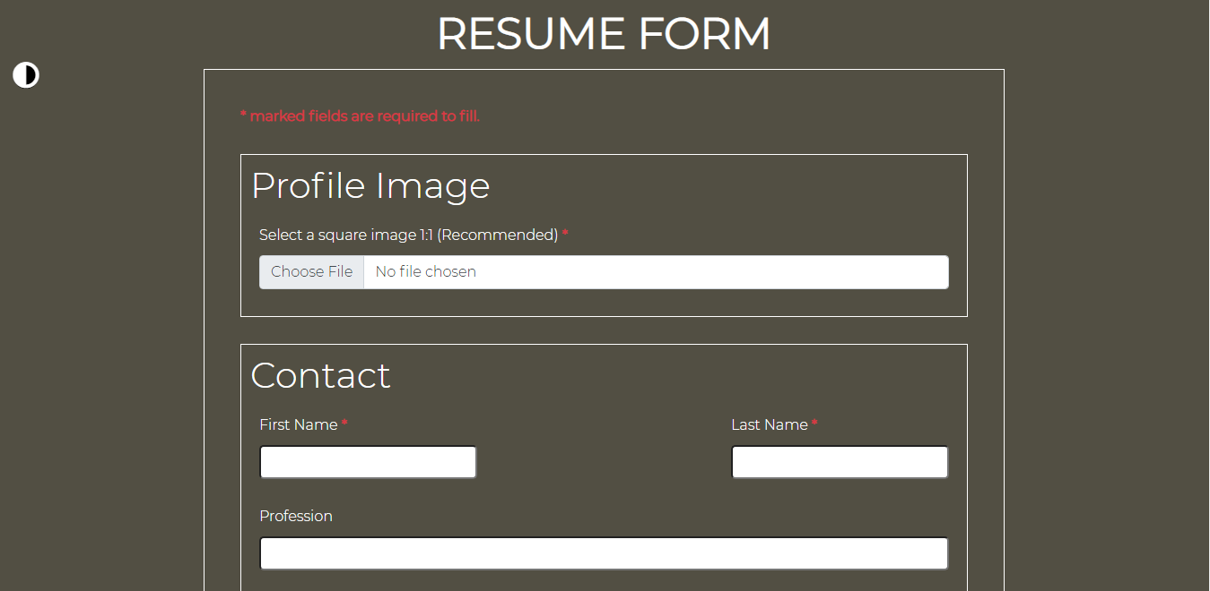
Fig . 7.2 Resume form (a)

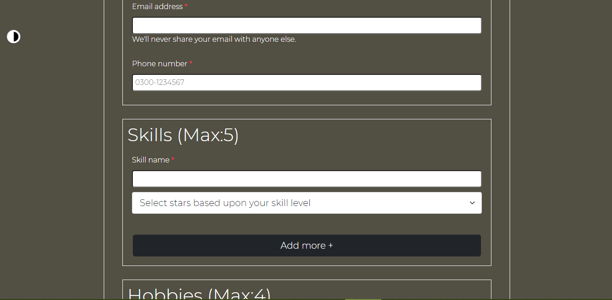
Fig. 7.3 Resume form (b)
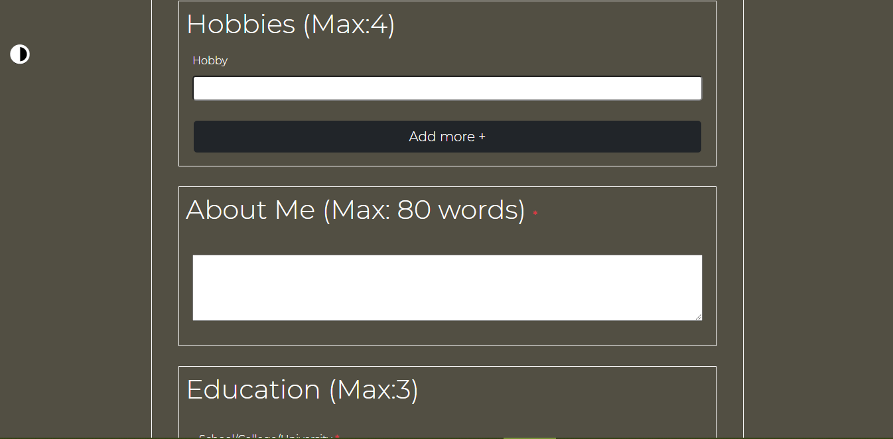
Fig.7.4 Resume form (c)
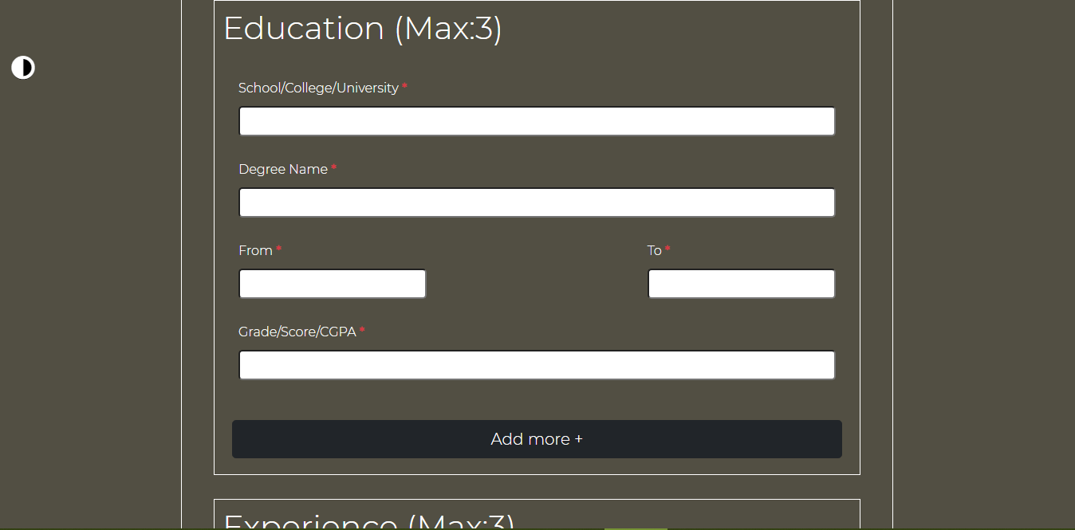
Fig.7.5 Resume form (d)
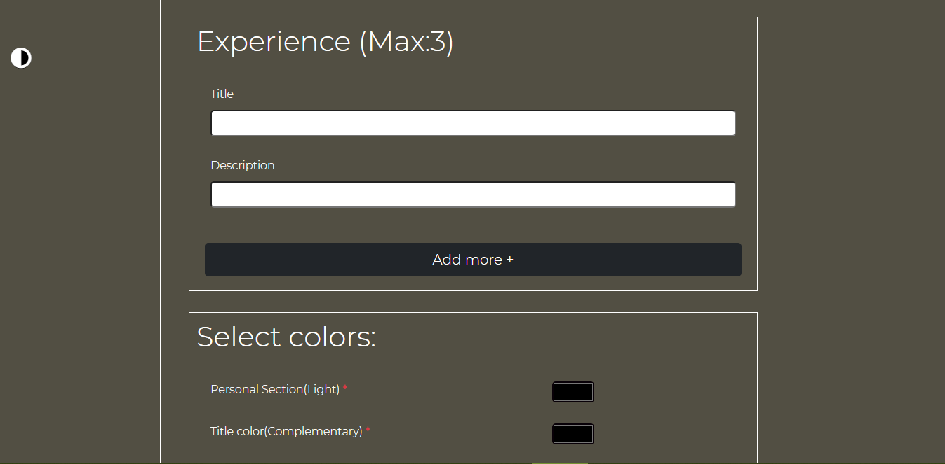
Fig.7.6 Resume form (e)
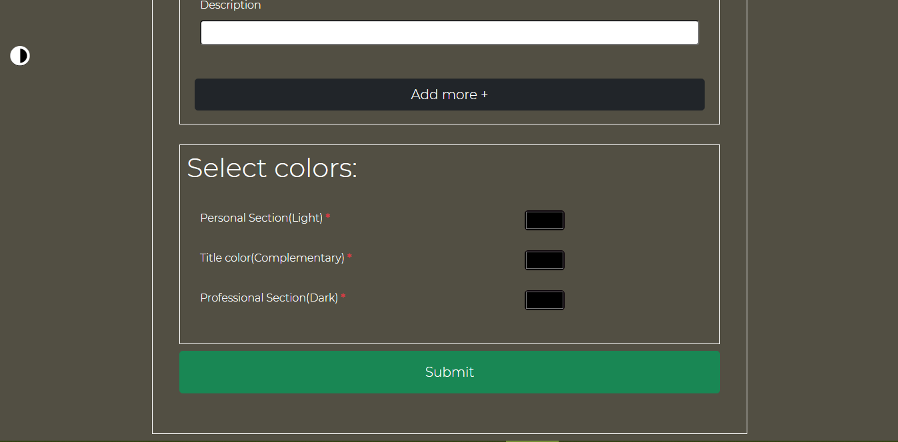
Fig.7.7 Resume form (f)

7.3 PAGE AFTER SUBMISSION
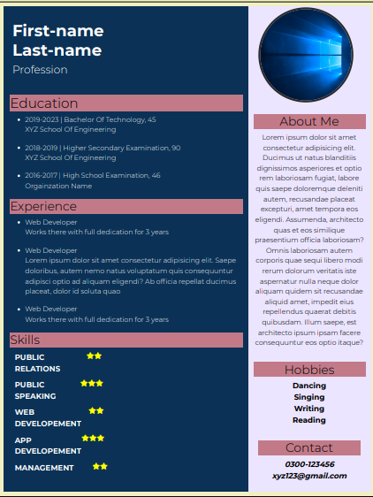
Fig.7.8 Submit page

8. CODING

There are eight files in our project :
- Index.html
- Home.css
- Resume-form.html
- Dark.css
- Light.css // for theme toggling
- App.js
- Style.css
- Submit.php
8.1 Index.html
<!DOCTYPE html>
<html lang="en">
<head>
<meta charset="UTF-8">
<meta http-equiv="X-UA-Compatible" content="IE=edge">
<meta name="viewport" content="width=device-width, initial-scale=1.0">

<!-- Bootstrap -->
<link href="https://cdn.jsdelivr.net/npm/bootstrap@5.0.2/dist/css/bootstrap.min.css" rel="stylesheet" integrity="sha384-EVSTQN3/azprG1Anm3QDgpJLIm9Nao0Yz1ztcQTwFspd3yD65VohhpuuCOmLASjC" crossorigin="anonymous">

<script src="https://cdn.jsdelivr.net/npm/bootstrap@5.0.2/dist/js/bootstrap.bundle.min.js" integrity="sha384-MrcW6ZMFYlzcLA8Nl+NtUVF0sA7MsXsP1UyJoMp4YLEuNSfAP+JcXn/tWtIaxVXM" crossorigin="anonymous"></script>

<!-- Stylesheet -->
<link rel="stylesheet" href="home.css">

<!-- Google font -->
<title>Automated Resume Generator</title>
</head>
<body>
<section id="home">

<div class="sec-divs">
<h1 class="text">Automated Resume Generator</h1>
<div class="head-div">
<a href="resume-form.html"><button class="btn btn-lg btn-light">
Resume form
</button></a>
<hr>
</div>
</div>
</section>
</body>
</html>
8.2 Resume-form.html
<!DOCTYPE html>
<html lang="en">
<head>
<meta charset="UTF-8">
<meta http-equiv="X-UA-Compatible" content="IE=edge">
<meta name="viewport" content="width=device-width, initial-scale=1.0">

<!-- Bootstrap Links -->
<link href="https://cdn.jsdelivr.net/npm/bootstrap@5.0.2/dist/css/bootstrap.min.css" rel="stylesheet" integrity="sha384-EVSTQN3/azprG1Anm3QDgpJLIm9Nao0Yz1ztcQTwFspd3yD65VohhpuuCOmLASjC" crossorigin="anonymous">
<script src="https://cdn.jsdelivr.net/npm/bootstrap@5.0.2/dist/js/bootstrap.bundle.min.js" integrity="sha384-MrcW6ZMFYlzcLA8Nl+NtUVF0sA7MsXsP1UyJoMp4YLEuNSfAP+JcXn/tWtIaxVXM" crossorigin="anonymous"></script>

<!-- Stylesheet -->
<link rel="stylesheet" id="theme" href="dark.css" type="text/css" media="">

<!-- favicon -->
<link rel="shortcut icon" href="images/favicon (2).ico" type="image/x-icon">

<!-- fontawesome -->
<script src="https://kit.fontawesome.com/0e5fe7cb89.js" crossorigin="anonymous"></script>

<title>Resume Generator</title>
</head>
<body>

<!-- Theme Toggler -->

<div class="bulb-box" onclick='toggleTheme()'>
<i class="fas fa-adjust bulb"></i>
</div>

<!-- Heading -->

<div class="container heading-container">
<h1 class="resume-heading heading text-center fw-bold">
resume form
</h1>

<!-- form container -->
<div class="container form-container">
<form action="submit.php" method="post" enctype="multipart/form-data">

<input type="hidden" name="token" value="HGsZOXpfNC">

<!-- Info -->

<div>
<p class="text-indent fs-6 text-danger fw-bold">
* marked fields are required to fill.
</p>
</div>

<!-- profile image section -->

<div class="container-fluid profile-image-container profile-container">

<h1 class="profile-image-heading heading">
Profile Image
</h1>

<div class="container content profile-content-container">
<label for="profile-image">
Select a square image 1:1 (Recommended) <span class="text-indent fs-6 text-danger fw-bold">*</span>
</label>
<input type="file" class="form-control" name = "profile-image" id="profile-image" accept="image/*" required>
</div>
</div>

<!-- Contact section -->
<div class="contact-container container-fluid">
<h1 class="heading">
Contact
</h1>
<div class="container contact-content-container">
<div class="row">

<div class="col-md content">
<label for="first-name">First Name <span class="text-indent fs-6 text-danger fw-bold">*</span></label>
<input type="text" name="first-name" id="first-name" required>
</div>

<div class="col content"></div>

<div class="col-md content">
<label for="last-name">Last Name <span class="text-indent fs-6 text-danger fw-bold">*</span></label>
<input type="text" name="last-name" id="last-name" required>
</div>

</div>
</div>
<div class="container content contact-content-container">
<label for="profession">Profession</label><br>
<input type="text" name="profession" id="profession" >
</div>

<div class="container content contact-content-container">
<label for="email">Email address <span class="text-indent fs-6 text-danger fw-bold">*</span></label><br>
<input type="email" name="email" id="email" required>
<div class="">We'll never share your email with anyone else.</div>
</div>

<div class="container content contact-content-container">
<label for="phone-number">Phone number <span class="text-indent fs-6 text-danger fw-bold">*</span></label><br>
<input type="text" name="phone-number" id="phone-number" placeholder="0300-1234567" required>
</div>

</div>

<!-- Skills section -->

<div class="skills-container container-fluid">
<h1 class="heading">
Skills (Max:5)
</h1>
<div class="container skills-content-container content">

<div>
<label for="skill1">Skill name <span class="text-indent fs-6 text-danger fw-bold">*</span></label><br>
<input type="text" name="skill1" id="skill1" required>

<select class="form-select form-select-lg mb-3 skill-level1" name="skill-level1" aria-label=".form-select-lg example" required>
<option selected>Select stars based upon your skill level</option>
<option value="1">1-Novice</option>
<option value="2">2-Advanced Beginner</option>
<option value="3">3-Competent</option>
<option value="4">4-Proficient</option>
<option value="5">5-Expert</option>
</select>
</div>

</div>
<div id="addSkill"></div>

<div class="container">
<input class="btn btn-lg btn-dark skill-btn" type="button" onclick="skillFunc()" value="Add more +">
</input>
</div>
</div>

<!-- Hobbies section -->

<div class="hobbies-container container-fluid">
<h1 class="heading">
Hobbies (Max:4)
</h1>
<div class="container hobbies-content-container content">
<div>
<label for="hobby1">Hobby</label><br>
<input type="text" name="hobby1" id="hobby1" >
</div>

</div>
<div id="addHobby"></div>
<div class="container">
<input class="btn btn-lg btn-dark hobbies-btn" value="Add more +">
</input>
</div>
</div>

<!-- About me section -->
<div class="container-fluid about-me-container">
<h1 class="about-me-heading heading">
About Me (Max: 80 words) <span class="text-indent fs-6 text-danger fw-bold">*</span>
</h1>
<div class="container about-me-content-container content">
<label for="about-me"></label>
<textarea name="about-me" id="about-me" required></textarea>
</div>
</div>

<!-- Education section -->
<div class="education-container container-fluid">
<h1 class="heading">
Education (Max:3)
</h1>

<div class="container content education-content-container">
<div class="container content education-content-container">
<label for="school-name1">
School/College/University <span class="text-indent fs-6 text-danger fw-bold">*</span>
</label>
<input type="text" name="school-name1" id="school-name1" required>

</div>
<div class="container content education-content-container">
<label for="degree1">Degree Name <span class="text-indent fs-6 text-danger fw-bold">*</span></label>
<input type="text" name="degree1" id="degree1" required>
</div>
<div class="container education-content-container">
<div class="row">
<div class="col-md content">
<label for="from1">From <span class="text-indent fs-6 text-danger fw-bold">*</span></label>
<input type="text" name="from1" id="from1" required>
</div>
<div class="col content"></div>
<div class="col-md content">
<label for="to1">To <span class="text-indent fs-6 text-danger fw-bold">*</span></label>
<input type="text" name="to1" id="to1" required>
</div>
</div>
</div>
<div class="container content education-content-container">
<label for="grade1">Grade/Score/CGPA <span class="text-indent fs-6 text-danger fw-bold">*</span></label><br>
<input type="text" name="grade1" id="grade1" required>
</div>
</div>
<div id="addEducation"></div>

<div class="container">
<input class="btn btn-lg btn-dark education-button" value="Add more +">
</input>
</div>
</div>

<!-- Experience section -->
<div class="experience-container container-fluid">
<h1 class="heading">
Experience (Max:3)
</h1>

<div class="container experience-content-container content">
<div>

<div class="container experience-content-container content">
<label for="title1">Title</label>
<input type="text" name="title1" id="title1">
</div>
<div class="container experience-content-container content">
<label for="description1">Description</label><br>
<input type="text" name="description1" id="description1">
</div>
</div>
</div>
<div id="addExperience"></div>
<div class="container">
<input class="btn btn-lg btn-dark experience-button" value="Add more +" >
</div>
</div>

<div class="colors-container container-fluid">
<h1 class="heading">
Select colors:
</h1>

<div class="container colors-content-container content">
<div>

<div class="container colors-content-container content row">
<label for="primary-color" class="col-lg-8 col-md">Personal Section(Light) <span class="text-indent fs-6 text-danger fw-bold">*</span> </label>
<input type="color" name="primary-color" class="col-lg-4 col-md" id="primary-color" required>
</div>

<div class="container colors-content-container content row">
<label for="complementary-color" class="col-lg-8 col-md"> Title color(Complementary) <span class="text-indent fs-6 text-danger fw-bold">*</span> </label>
<input type="color" name="complementary-color" class="col-lg-4 col-md" id="complementary-color" required>
</div>

<div class="container colors-content-container content row">
<label for="secondary-color" class="col-lg-8 col-md">Professional Section(Dark) <span class="text-indent fs-6 text-danger fw-bold">*</span> </label><br>
<input type="color" name="secondary-color" id="secondary-color" class="col-lg-4 col-md" required>
</div>
</div>
</div>

</div>

<!-- submit button -->
<button type="submit" value="Submit" class="btn btn-lg btn-success submit-button p-3"> Submit </button>

</form>
</div>
</div>

<script src="app.js"></script>
</body>
</html>

8.3 App.js
// Button Logic
const submitButton = document.querySelector('.submit-button');
const expButton = document.querySelector('.experience-button');
const educationButton = document.querySelector('.education-button');
const hobbyButton = document.querySelector('.hobbies-btn');
const skillButton = document.querySelector('.skill-btn');

var skillCount=1;
var eduCount=1;
var expCount=1;
var hobbyCount=1;

function toggleTheme(){
var themeSelect = document.getElementById("theme");

if(themeSelect.getAttribute('href') == "dark.css")
{
themeSelect.setAttribute('href','light.css');
}
else
{
themeSelect.setAttribute('href','dark.css');
}

function skillFunc(){

let addSkill = document.getElementById('addSkill');

if(skillCount<5)
{
skillCount++;

var field =

`<div class="container skills-content-container content">
<label for="skill${skillCount}">Skill Name</label>
<input type="text" class="skill${skillCount}" name="skill${skillCount}" id="skill${skillCount}">
<select class="form-select form-select-lg mb-3 skill-level${skillCount}" name="skill-level${skillCount}">
<option value="">Select stars based upon your skill level</option>
<option value="1">1 - Novice</option>
<option value="2">2 - Advanced Beginner</option>
<option value="3">3 - Competent</option>
<option value="4">4 - Proficient</option>
<option value="5">5 - Expert</option>
</select>
</div>`;

console.log(field);
var htmlObject = document.createElement('div');

htmlObject.innerHTML = field;
addSkill.insertAdjacentElement("beforeend", htmlObject);
}
if(skillCount==5)
{
skillButton.style = "display:none";
}

}

hobbyButton.addEventListener('click',function(){

let addHobby = document.getElementById('addHobby');

if(hobbyCount<4)
{
++hobbyCount;
var field =
`<div class="container hobbies-content-container content">
<label for="hobby${hobbyCount}">Hobby</label>
<input type="text" name="hobby${hobbyCount}" class="">
</div>`;

var htmlObject = document.createElement('div');
htmlObject.innerHTML=field;
addHobby.insertAdjacentElement("beforeend", htmlObject);
}
if(hobbyCount==4)
{
hobbyButton.style = "display:none";
}

});
educationButton.addEventListener('click',function(){

let addEducation = document.getElementById('addEducation');

if(eduCount<3)
{
++eduCount;
var field =
`
<div class="container content education-content-container">
<div class="container content education-content-container">
<label for="exampleInputEmail1">
School/College/University
</label>
<input type="text" name="school-name${eduCount}" id="school-name${eduCount}">

</div>
<div class="container content education-content-container">
<label for="exampleInputEmail1">Degree Name</label>
<input type="text" name="degree${eduCount}" id="degree${eduCount}" >
</div>
<div class="container education-content-container">
<div class="row">
<div class="col-md content">
<label for="exampleInputEmail1">From</label>
<input type="text" name="from${eduCount}" id="from${eduCount}" >
</div>
<div class="col content"></div>
<div class="col-md content">
<label for="exampleInputEmail1">To</label>
<input type="text" name="to${eduCount}" id="to${eduCount}" >
</div>
</div>
</div>
<div class="container content education-content-container">
<label for="exampleInputEmail1">Grade/Score/CGPA</label><br>
<input type="text" name="grade${eduCount}" id="grade${eduCount}" >
</div>
</div>
`;
var htmlObject = document.createElement('div');
htmlObject.innerHTML=field;
addEducation.insertAdjacentElement("beforeend", htmlObject);
}
if(eduCount==3)
{
educationButton.style = "display:none";
}

});

expButton.addEventListener('click',function(){

let addExperience = document.getElementById('addExperience');

if(expCount<3)
{
++expCount;
var field =
`
<div class="container experience-content-container content">
<div>
<div class="container experience-content-container content">
<label for="titlexampleInputEmail1e">Title</label>
<input type="text" name="title${expCount}" id="title${expCount}">
</div>
<div class="container experience-content-container content">
<label for="exampleInputEmail1">Description</label><br>
<input type="text" name="description${expCount}" id="description${expCount}">
</div>

</div></div>`;
var htmlObject = document.createElement('div');
htmlObject.innerHTML=field;
addExperience.insertAdjacentElement("beforeend", htmlObject);
}
if(expCount==3)
{
expButton.style = "display:none";
}
});

}

8.4 Submit.php
<?php
define('Token','HGsZOXpfNC');
$skills = [];
$skill_levels = [];
$hobbies = [];
$institutes = [];
$degrees = [];
$froms = [];
$tos = [];
$grades = [];
$titles = [];
$descriptions = [];

if(Token == $_POST['token'])
{
$temp_profile = $_FILES['profile-image']['tmp_name'];
$profile = $_FILES['profile-image']['name'];
move_uploaded_file($temp_profile,'images/'.$profile);
$first_name = $_POST['first-name'];
$last_name = $_POST['last-name'];
$profession = $_POST['profession'];
$email = $_POST['email'];
$phone = $_POST['phone-number'];
$about_me = $_POST['about-me'];

$primary_color = $_POST['primary-color'];
$complementary_color = $_POST['complementary-color'];
$secondary_color = $_POST['secondary-color'];

array_push($skills,$_POST['skill1']);
array_push($skill_levels,intval($_POST['skill-level1']));

array_push($hobbies,$_POST['hobby1']);
array_push($institutes,$_POST['school-name1']);
array_push($degrees,$_POST['degree1']);
array_push($froms,$_POST['from1']);
array_push($tos,$_POST['to1']);
array_push($grades,$_POST['grade1']);
array_push($titles,$_POST['title1']);
array_push($descriptions,$_POST['description1']);

if(isset($_POST['skill2']) && !empty($_POST['skill2']))
{
if(isset($_POST['skill-level2']) && !empty($_POST['skill-level2']))
{
array_push($skills,$_POST['skill2']);
array_push($skill_levels,intval($_POST['skill-level2']));
}
}

if(isset($_POST['skill3']) && !empty($_POST['skill3']))
{
if(isset($_POST['skill-level3']) && !empty($_POST['skill-level3']))
{
array_push($skills,$_POST['skill3']);
array_push($skill_levels,intval($_POST['skill-level3']));
}
}

if(isset($_POST['skill4']) && !empty($_POST['skill4']))
{
if(isset($_POST['skill-level4']) && !empty($_POST['skill-level4']))
{
array_push($skills,$_POST['skill4']);
array_push($skill_levels,intval($_POST['skill-level4']));
}
}

if(isset($_POST['skill5']) && !empty($_POST['skill5']))
{
if(isset($_POST['skill-level5']) && !empty($_POST['skill-level5']))
{
array_push($skills,$_POST['skill5']);
array_push($skill_levels,intval($_POST['skill-level5']));
}
}

if(isset($_POST['hobby2']) && !empty($_POST['hobby2']))
{
array_push($hobbies,$_POST['hobby2']);
}
if(isset($_POST['hobby3']) && !empty($_POST['hobby3']))
{
array_push($hobbies,$_POST['hobby3']);
}
if(isset($_POST['hobby4']) && !empty($_POST['hobby4']))
{
array_push($hobbies,$_POST['hobby4']);
}

if(isset($_POST['school-name2']) && !empty($_POST['school-name2']))
{
if(isset($_POST['degree2']) && !empty($_POST['degree2']))
{
if(isset($_POST['from2']) && !empty($_POST['from2']))
{
if(isset($_POST['to2']) && !empty($_POST['to2']))
{
if(isset($_POST['grade2']) && !empty($_POST['grade2']))
{
array_push($institutes,$_POST['school-name2']);
array_push($degrees,$_POST['degree2']);
array_push($froms,$_POST['from2']);
array_push($tos,$_POST['to2']);
array_push($grades,$_POST['grade2']);
}
}
}
}
}

if(isset($_POST['school-name3']) && !empty($_POST['school-name3']))
{
if(isset($_POST['degree3']) && !empty($_POST['degree3']))
{
if(isset($_POST['from3']) && !empty($_POST['from3']))
{
if(isset($_POST['to3']) && !empty($_POST['to3']))
{
if(isset($_POST['grade3']) && !empty($_POST['grade3']))
{
array_push($institutes,$_POST['school-name3']);
array_push($degrees,$_POST['degree3']);
array_push($froms,$_POST['from3']);
array_push($tos,$_POST['to3']);
array_push($grades,$_POST['grade3']);
}
}
}
}
}

if(isset($_POST['title2']) && !empty($_POST['title2']))
{
if(isset($_POST['description2']) && !empty($_POST['description2']))
{
array_push($titles,$_POST['title2']);
array_push($descriptions,$_POST['description2']);
}
}

if(isset($_POST['title3']) && !empty($_POST['title3']))
{
if(isset($_POST['description3']) && !empty($_POST['description3']))
{
array_push($titles,$_POST['title3']);
array_push($descriptions,$_POST['description3']);
}
}

}
else
{
header('location: /resumegenerator');
}
?>

<!DOCTYPE html>
<html lang="en">
<head>
<meta charset="UTF-8">
<meta http-equiv="X-UA-Compatible" content="IE=edge">
<meta name="viewport" content="width=device-width, initial-scale=1.0">

<!-- fab awesome icon -->
<link rel="stylesheet" href="https://cdnjs.cloudflare.com/ajax/libs/font-awesome/5.15.2/css/all.min.css">

<!-- bootsrap files -->
<link href="https://cdn.jsdelivr.net/npm/bootstrap@5.0.2/dist/css/bootstrap.min.css" rel="stylesheet" integrity="sha384-EVSTQN3/azprG1Anm3QDgpJLIm9Nao0Yz1ztcQTwFspd3yD65VohhpuuCOmLASjC" crossorigin="anonymous">

<script src="https://cdn.jsdelivr.net/npm/bootstrap@5.0.2/dist/js/bootstrap.bundle.min.js" integrity="sha384-MrcW6ZMFYlzcLA8Nl+NtUVF0sA7MsXsP1UyJoMp4YLEuNSfAP+JcXn/tWtIaxVXM" crossorigin="anonymous"></script>

<!-- stylesheet -->
<link rel="stylesheet" href="style.css" media="all">

<!-- icon -->
<link rel="shortcut icon" href="images/favicon (2).ico" type="image/x-icon">

<title><?php echo ucwords($first_name). ' Resume'; ?></title>
</head>
<body>

<!-- Main container -->
<div class="row main-heading form-container heading-container container-fluid">

<!-- Left part -->
<div class="zone-2 col-8 container-fluid" style="background-color: <?php echo $secondary_color ?>">

<!-- Name and surname -->
<div class ="heading">
<div class="profile-col content">
<div class="headTitle">
<b> <h1 class='fs-1'><?php echo ucwords($first_name).' ';?><?php echo ucwords($last_name);?></b></h1>
</div>
<div class="subTitle">
<h1 class="fs-4"><?php echo ucwords($profession);?><h1>
</div>
</div>
</div>

<!-- Education content -->
<div class="group-2 content">
<div class="title" style="background-color: <?php echo $complementary_color ?>">
<div class="box">
<h2>Education</h2>
</div>
</div>
<div class="desc">
<?php
for($i=0; $i<count($institutes);$i++)
{
echo "<ul>
<li>
<div class='msg-1'>" . $froms[$i] . "-" . $tos[$i]. " | " . ucwords($degrees[$i]) . ", " . $grades[$i]. "</div>
<div class='msg-2'>" . ucwords($institutes[$i]) . "</div>
</li>
</ul>";
}
?>
</div>
</div>

<!-- Experience section -->
<div class="group-3 content">
<div class="title" style="background-color: <?php echo $complementary_color ?>">
<div class="box">
<h3>Experience</h3>
</div>
</div>
<div class="desc">
<?php
for($i=0; $i<count($titles);$i++)
{
echo "<ul>
<li>

<div class='msg-2'>" . ucwords($titles[$i]) ."</div>
<div class='msg-3'>" . ucfirst($descriptions[$i]) . "</div>
</li>
</ul>";
}
?>
</div>
</div>

<!-- Skills section -->
<div class="personal-box content">
<div class="title" style="background-color: <?php echo $complementary_color ?>">
<h3>Skills</h3>
</div>
<?php
for($j=0; $j<count($skills); $j++){
echo "<div class='skill-1'>
<p>
<strong>" . strtoupper($skills[$j]) . "</strong>

<span class='progress'>";
for($i=0;$i<$skill_levels[$j];$i++){
echo '<i class="fas fa-star active"></i>';

}

echo '</span></p></div>';

}
?>
</div>
</div>

<!-- end of left side -->
<!-- right side -->
<div class="col-4 zone-1 container-fluid" style="background-color: <?php echo $primary_color ?>">
<!-- image -->
<div class="toCenter">
<img src="images/<?php echo $profile;?>" class="profile circle">
</div>
<!-- about me section -->
<div class="group-1 content">
<div class="title" style="background-color: <?php echo $complementary_color ?>">
<div class="box">
<h3>About Me</h3>
</div>
</div>
<div class="desc">
<?php echo $about_me;?>
</div>
</div>
<!-- hobbies section -->
<div class="hobbies-box content">
<div class="title" style="background-color: <?php echo $complementary_color ?>">
<h3>Hobbies</h3>
</div>
<?php
foreach($hobbies as $hobby)
{
echo "<div class=''>
<div class='circle'></div>
<div><strong>" . ucwords($hobby) . "</strong></div>
</div>";
}
?>
</div>
<!-- contact section -->
<div class="contact-box content">
<div class="title" style="background-color: <?php echo $complementary_color ?>">
<h3>Contact</h3>
</div>
<div class="call">
<b> <i class="text"><?php echo $phone;?></i></b>
</div>
<div class="email">
<b> <i class="text"><?php echo $email;?></i></b>
</div>
</div>
</div>
</div>
</body>
</html>
9. CONCLUSION
- With our website you can easily create a simple and professional just by simply filing the resume form.
- Resume can be downloaded in PDF format.
- When you’re making a personal resume website, the look, the feel, and the message are entirely up to you. You’re not bound by the space you have on a sheet of paper
- Simple as that. If you know how to set up your own resume website, you demonstrate you’re tech-savvy.
- Recruiters who’d bother reading your references and client testimonials are few and far between. Unlike your resume website guests, who made an effort to pay a visit.
- You can keep your resume website up to date very easily by our website, and include as many details as you wish. A traditional resume gives the recruiter a glimpse into your professional history and achievements. Your resume website can go much deeper.

10. LIMITATIONS
- The website is not responsive now.
- Recommended to use on desktop only.
- No Login page available for future reference.

11. FUTURE ENHANCEMENTS
- Will add more template styles so that user can select the design themselves.
- We will make it responsive.
- We will create login forms for saving resumes for future
- User Authentication.

12. BIBLIOGRAPHY
- Colors are taken form colorhunt.co website.
- https://www.w3schools.com/php/default.asp
- https://getbootstrap.com/docs/5.1/getting-started/introduction
- https://fonts.google.com
- https://fontawesome.com

